Lab 2 - Manage Copilot features in Dynamics 365 Contact Center
Duration: 15 mins

Introduction
In this lab, you will learn how to configure and enable Copilot AI features in the Dynamics 365 Contact Center environment. You will use the Power Platform admin center to manage environment settings, enable Bing Search integration, and configure Copilot capabilities such as knowledge base access and AI-powered productivity tools for agents

Task 1 - Enable Generative AI Features in the Power Platform Admin Center
In this task, you will access the Power Platform admin center to enable Generative AI features, review Bing Search options, and ensure the Copilot service can use the best data sources for intelligent responses.
- Open a new tab in the browser. Sign in to the Power Platform admin center - https://admin.powerplatform.microsoft.com/!! With the credentials provided to execute the lab in the home tab.
- In the left side panel, select the Manage option and then navigate to Environments.
- 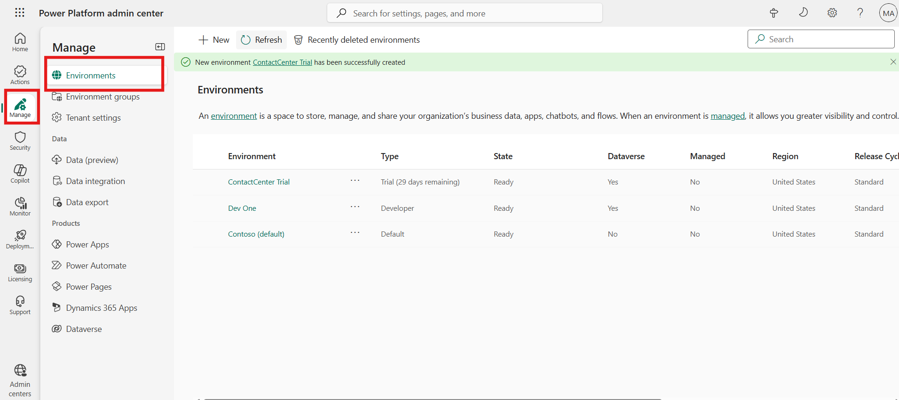
- Select your Contact Center Trial environment.
- 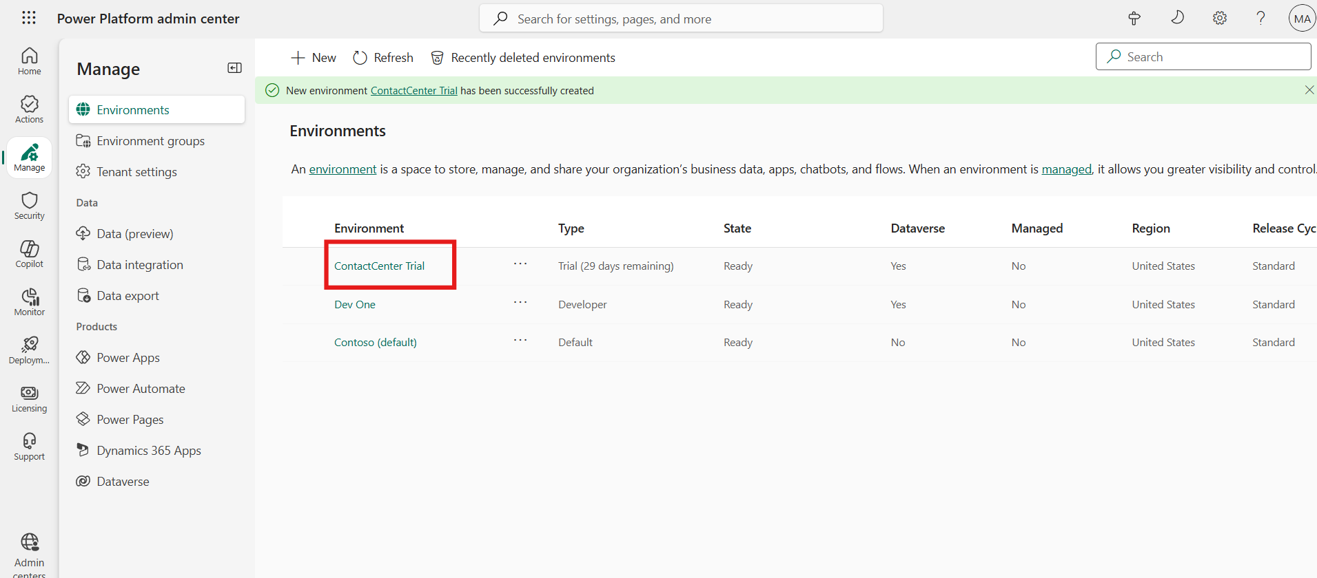
- You will find the Environment URL under Details. This will take you to Customer Service page.
- On the Power Platform admin center page, scroll down until you see the Generative AI features card. Now, select Edit.
- 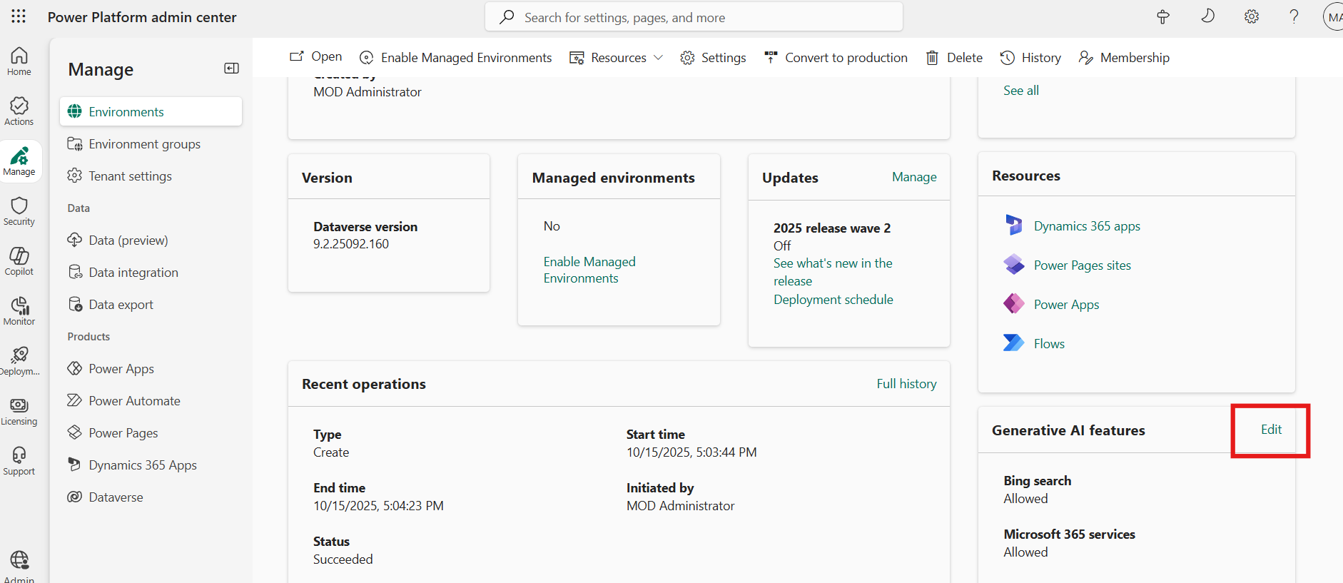
- Review the terms of use and select the Bing Search checkbox if it is not selected. When the Bing Search feature is turned on, your copilot in Microsoft Copilot Studio can use the data sources you provided, but it can use Bing’s APIs to index the results better and find the best answer from within your data sources.
- If any changes have been made, select Save to confirm them; otherwise, select Cancel.
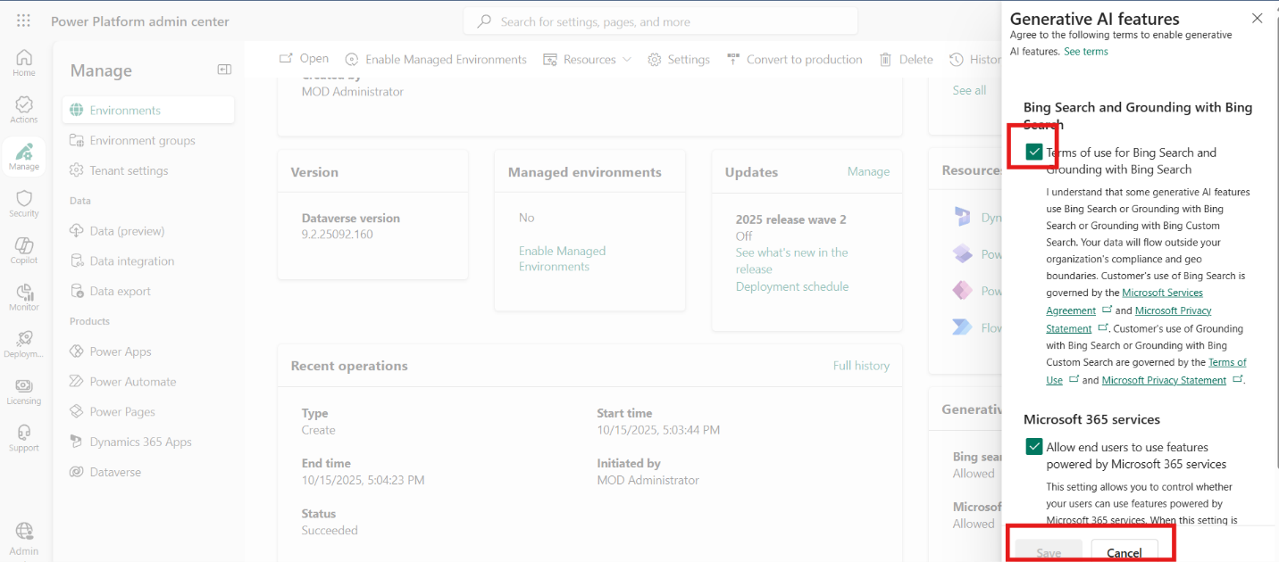

Task 2 - Configure Copilot for Questions and Emails
In this task, you will enable the Copilot feature for handling customer questions and emails in the Copilot Service admin center. You will also include a knowledge source base to improve the quality of Copilot-generated answers.
- Switch back to Copilot Service admin center tab.
- Select Productivity under Support experience.
- Select Manage for Copilot for questions and emails.
- 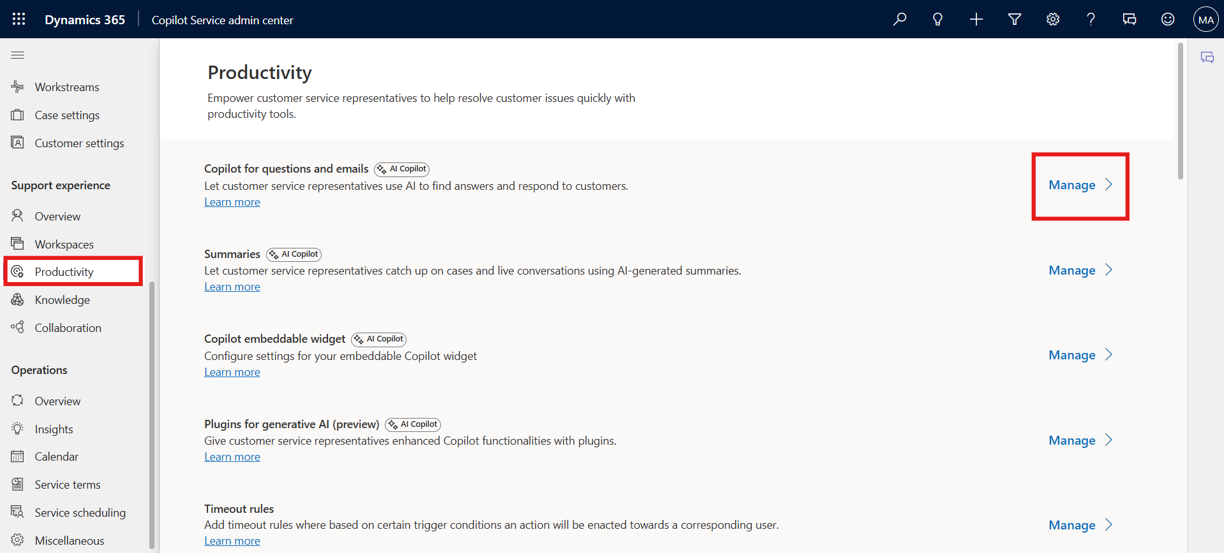
- Scroll down and select Include a knowledge source base check box.
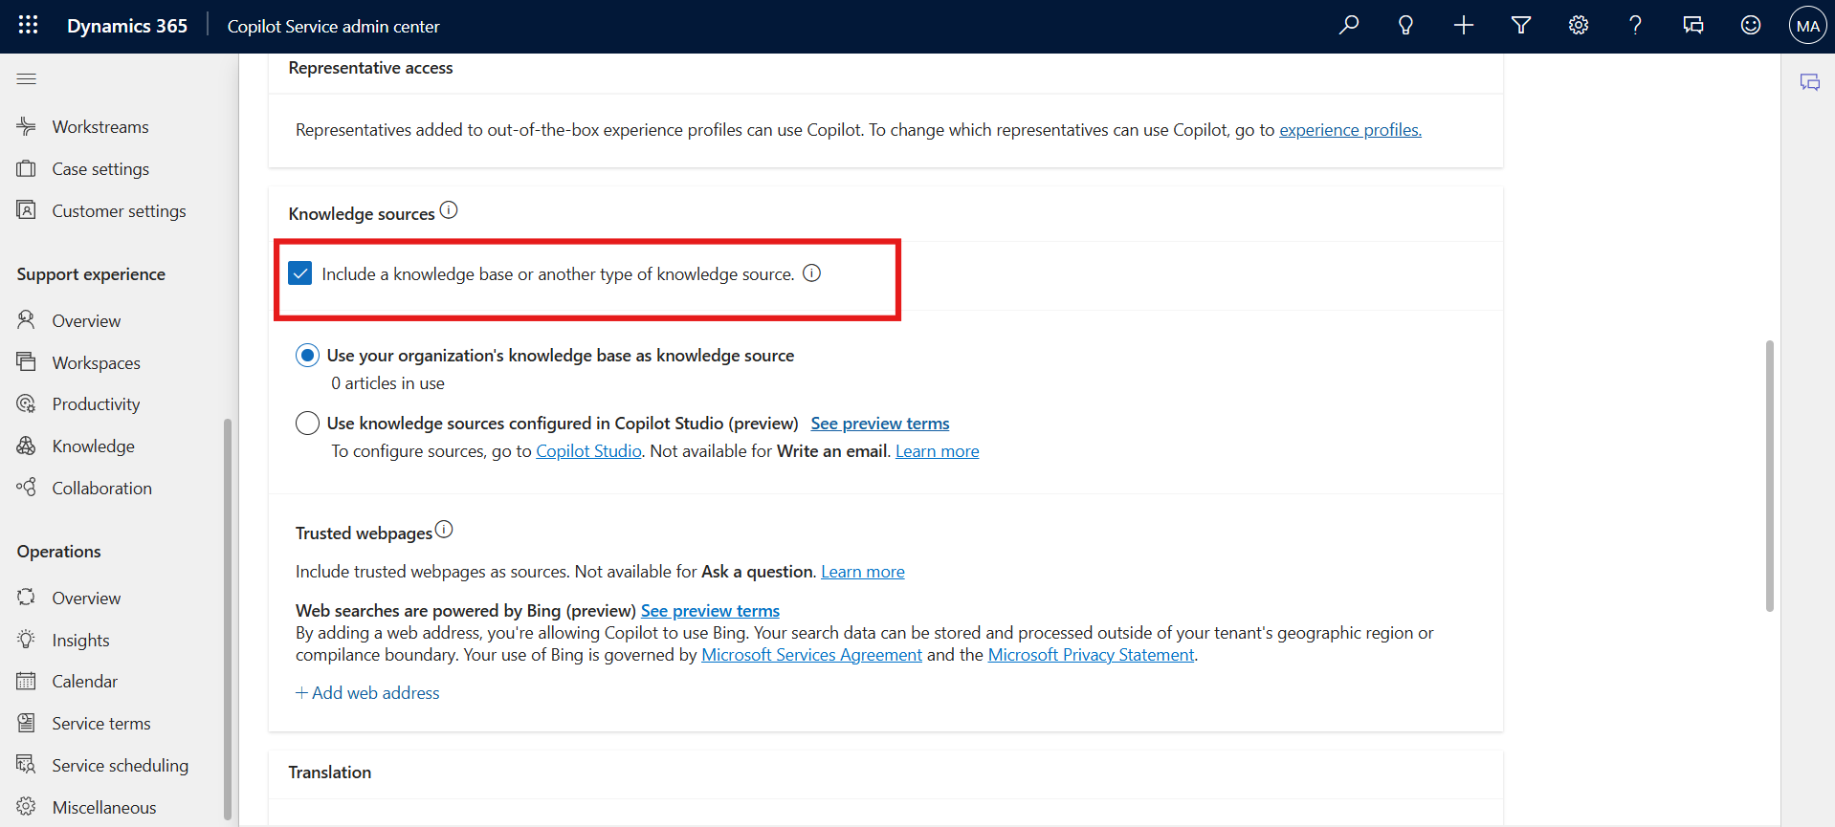
- Scroll up and then Select the checkbox for Ask a question.
- Select Save and close.
- 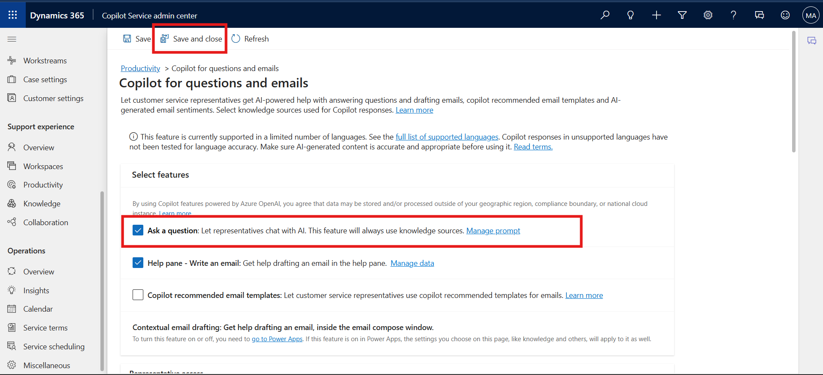

Task 3 - Enable Copilot AI Features in Agent Experience Profile
In this task, you will configure the Customer Service Trial agent experience profile to ensure that all Copilot AI features—such as suggesting responses, writing emails, and answering questions—are enabled within the productivity pane.
- On the left navigation pane, Under Support experience, select Workspaces.
- Select Manage under Experience profiles.
- 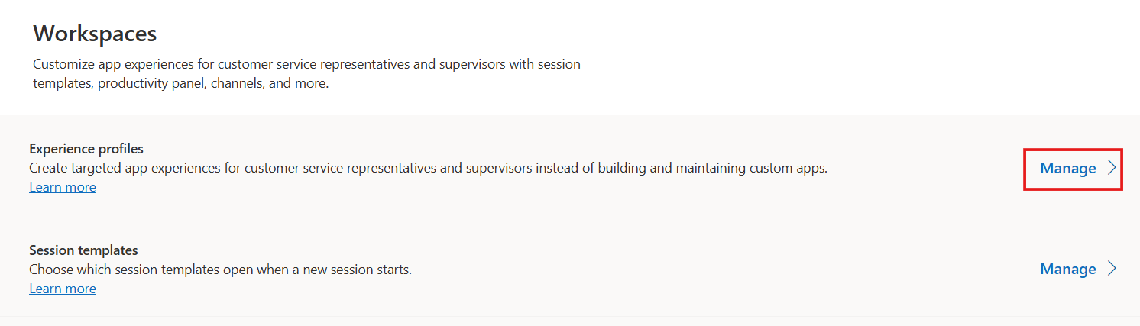
- Select the Customer Service Trial profile agent experience profile from the list.
- 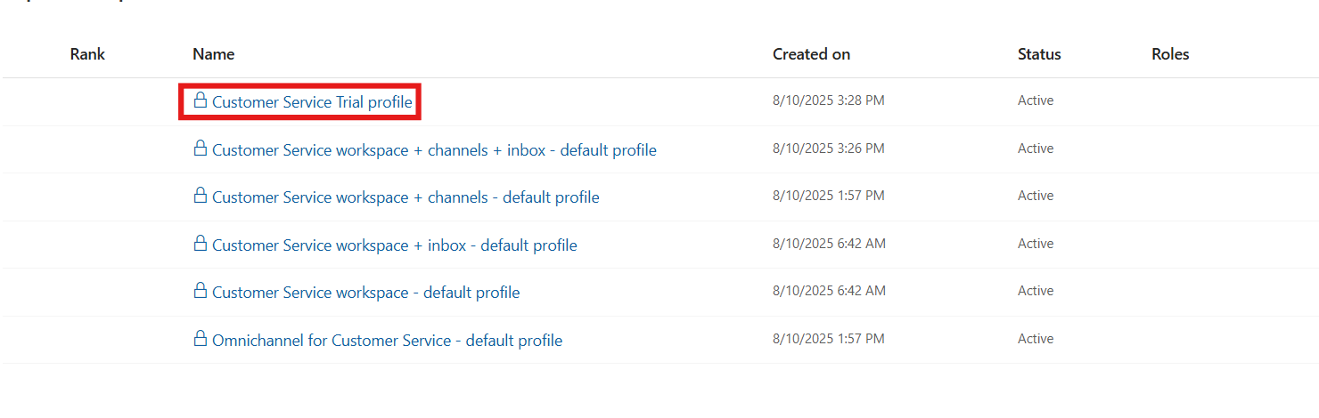
- On the Productivity Pane, make sure Copilot help pane toggle is ON so that agents can use the Copilot features such suggest a response, ask a question, and write an email on the productivity pane.
- 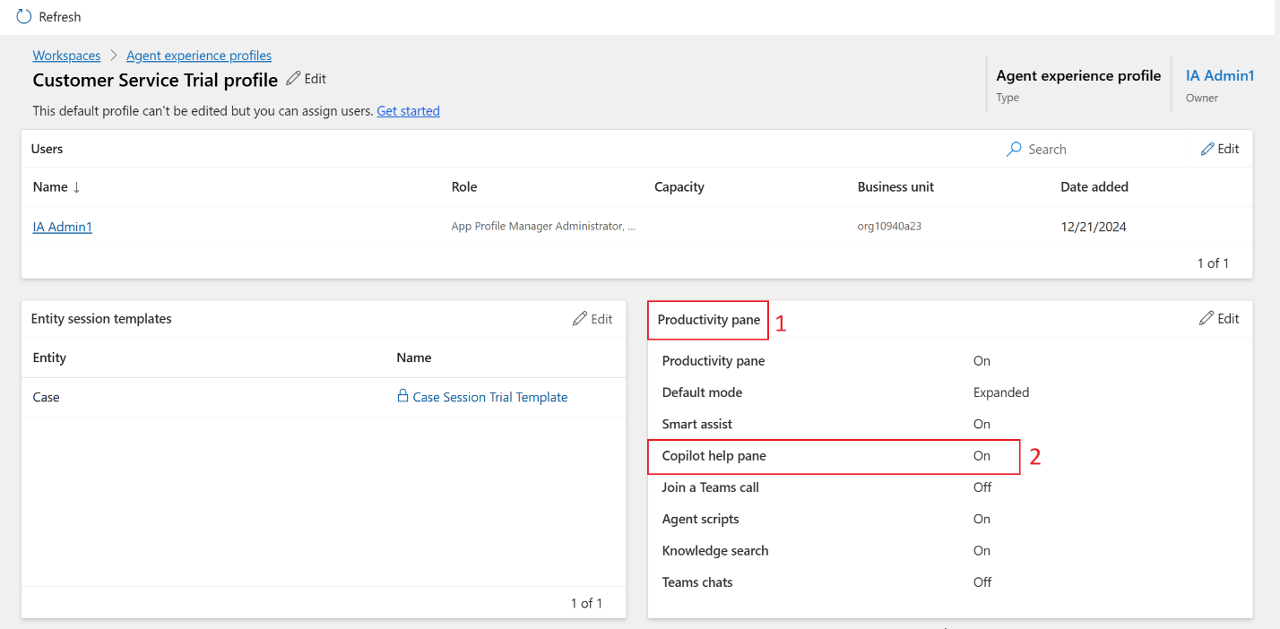
- Scroll down to Copilot AI features section. Make sure that all the Copilot AI features are enabled.
- 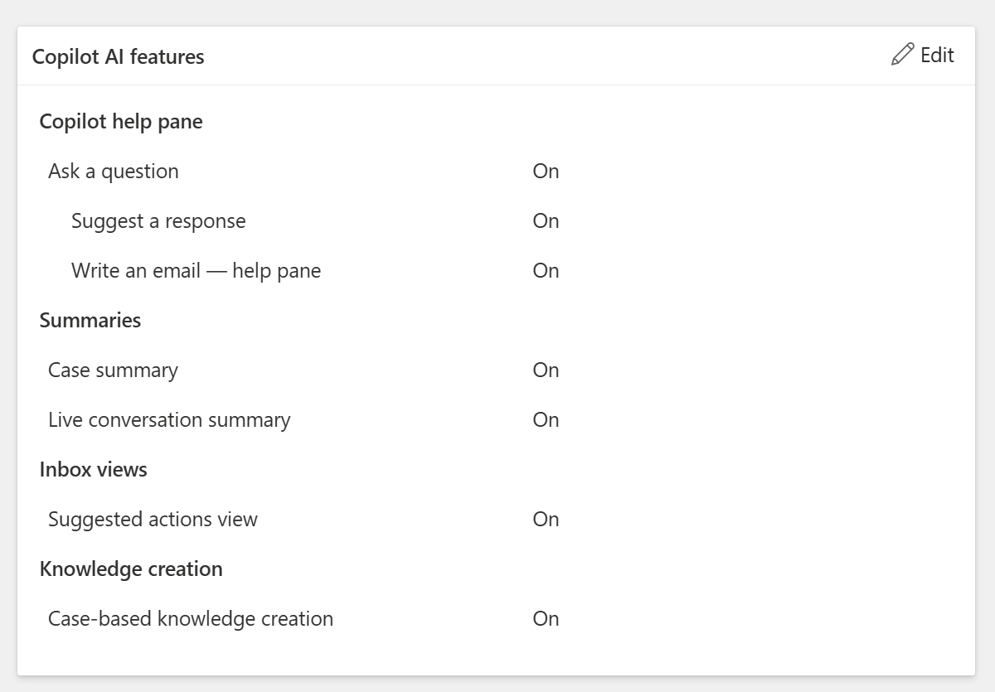\

Conclusion
By completing this lab, you have successfully configured Copilot AI capabilities within the Dynamics 365 Contact Center. You enabled generative AI features, integrated Bing Search, and activated key productivity enhancements to empower agents with intelligent assistance during customer interactions.

